# **Hope**

Isaiah 9:2

“The people who walked in darkness have seen a great light; those who dwelt in a land of deep darkness, on them has light shined.”

John 8:12

Jesus spoke to them, saying, ‘I am the light of the world. Whoever follows me will never walk in darkness but will have the light of life.’

Devotion

This is the first week of Advent. It is a time to think about what is means to

celebrate Jesus and to follow Jesus. The Bible says that Jesus is the light of the world. Jesus loves us and shows us the way out of the darkness. Jesus shows us the way to live. We have many lights around us at Christmas time to remind us that Jesus is the light of the world.

Song

O Come All Ye Faithful

Prayer

*Thank you, Jesus, for coming to earth and for your promise to come again. Thank you, Jesus, for being our light so we know how to live. AMEN*

Talk About Hope

1. Ask each person to talk about a special Christmas celebration from the past. Talk about what you are looking forward to this Christmas. How does Christmas bring you hope?
2. Share the responsibility of sending people cards this year. Give thanks for the people you are sending them to. How will these cards bring light and hope to their life?

3. Sort through your Christmas ornaments and find those that symbolize the “Light” of Jesus

who is the Light of the World. What help does the light of Jesus give to you?

4. What are you hopeful for this Christmas?

Activities

1. Make a memory book with all the pictures you will draw during Advent.
2. Make a special ornament to take to someone in the community who lives alone, or if possible invite him/her, or a family to your advent devotions.
3. 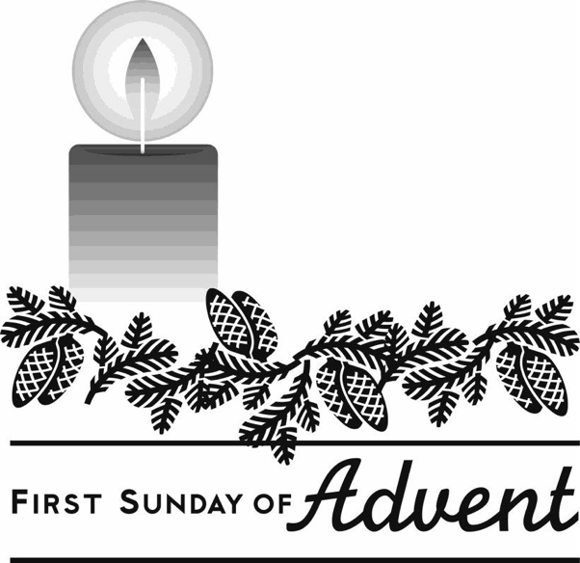Secret Angels: focus on the gift of giving in nonmaterial ways by drawing names within your family so that each person has a secret person to do something special for during Advent. It can include gifts of time, service, prayers, special notes….but not

bought gifts. A good time to reveal who the identify of the secret angels is the 4th Sunday of

Advent.

1. Read passages in scripture about giving and receiving gifts: Mt 1:18; 2:12; 6:1-4; 7:7-12:

25:35-40 (What is God’s gift to us? What do the

passages say about giving? What do you feel about giving and receiving a gift?)

# **Peace**

Luke 2:1-7

In those days a decree went out from Caesar Augustus that all the world should be enrolled.

This was the first enrollment, when Quirinius was governor of Syria. And all went to be enrolled, each to his own city. And Joseph also went up from Galilee, from the city of Nazareth,

to Judea, to the city of David, which is called Bethlehem, because he was of the house and lineage of David, to be enrolled with Mary, his betrothed, who was with child. And while they were there, the time came for her to be delivered. And she gave birth to her first-born son and wrapped him in swaddling cloths, and laid him in a manger, because there was no place for them in the inn.

Devotion

This is the second week of Advent. This is the day that we remember that Mary and Joseph are on the way to Bethlehem. Their journey from Nazareth to Bethlehem was over 70 miles. We are also on a journey. We are on our way to celebrate Christmas, and the birth of Jesus in Bethlehem.

Song

O Little Town of Bethlehem

Prayer

*Lord, help us to listen to you and learn more about you on our journey. Thank you for protecting us as we go to school and visit our friends. AMEN.*

Talk About Peace and Journey

1. Talk about daily trips that you make. What kind of transportation do you use? What is fun and what is difficult about your daily trips? What would it be like on a donkey?
2. Think about the people you know who live far away. What would it be like to travel there by donkey? What are the different ways you can travel this year?
3. If you are traveling this Christmas, what kind of gifts can you bring that show that you are learning to follow Jesus who shows us the way to live?
4. Talk about what your faith journey with Jesus is like now. What was it like in the past?
5. How does Jesus bring peace to your life? How does Jesus bring peace to the world?

Activities

1. Light two candles each night at mealtime. Pray that you and others will experience

God’s peace through Jesus Christ.

1. Pray for your travels or for relatives that may be traveling this Christmas.
2. Draw a picture of the journey that Mary and Joseph took to Bethlehem.
3. 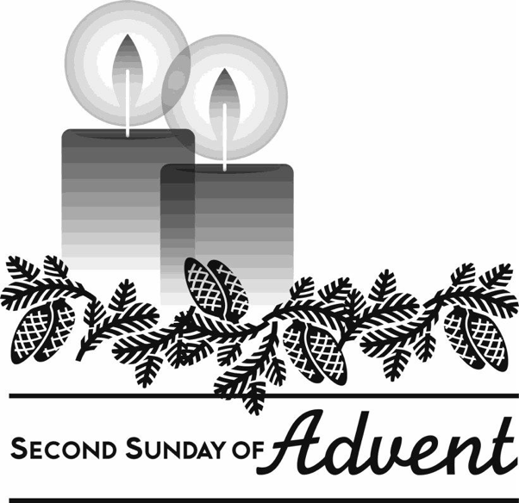Draw a picture of the journey you might take to see loved ones.

# **Joy**

Luke 1:46-47

And Mary said, "My soul magnifies the Lord, and my spirit rejoices in God my Savior.”

Luke 2:8-10

And in that region there were shepherds out in the field, keeping watch over their flock by night. And an angel of the Lord appeared to them, and the glory of the Lord shone around them, and they were filled with fear. And the angel said to them, "Be not afraid; for behold, I bring you good news of great joy which will come to all the people.”

Devotion

This is the third week of Advent, the Sunday of Joy! Mary was not afraid but joyful because of the Lord was with her. The angels comforted the frightened shepherds out on the dark hillside with the joy of the good news. Because of our relationship with Christ, we can experience joy and peace.

Song

Away in a Manger

Prayer

*Lord, today we rejoice. We rejoice because our Lord and Savior, Jesus is born in Bethlehem. Fill our hearts and our days with joy. We rejoice that you are with us always. AMEN*

Talk About Joy

1. Talk about the gifts you are giving to others and the joy it brings you when someone is excited about your gift.
2. Talk about what gift you will bring to Jesus.
3. Share something joyful that happened today or this week. Share about something that you need to pray about.
4. What are you most excited about for Christmas?

Activities

1. Wrap a present to Jesus and put under the tree with a slit on top. Throughout Advent drop in pieces of paper on which you have written ways you are sharing the light of Jesus

with others.

1. Make a placemat with cardboard using the Christmas cards you have received. Put clear contact paper over it and give it to a relative or neighbor as a gift.
2. Draw a picture of what you have learned this year about Christmas.
3. 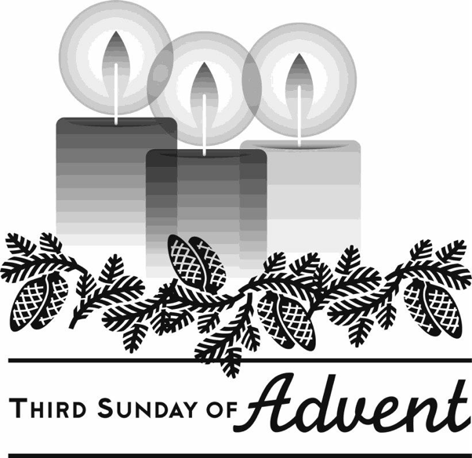Each time you turn on the Christmas lights in

your home say, “Christ is the light of the world, the joy of our hearts.”

# **Love**

Luke 2:15-20

When the angels went away from them into heaven, the shepherds said to one another, "Let us go over to Bethlehem and see this thing that has happened, which the Lord has made known to us." And they went with haste, and found Mary and Joseph, and the babe lying in a manger.

And when they saw it they made known the saying which had been told them concerning this child; and all who heard it wondered at what the shepherds told them. But Mary kept all these things, pondering them in her heart.

And the shepherds returned, glorifying and praising God for all they had heard and seen, as it had been told them.

Devotion

Mary and Joseph are with the baby Jesus in the stable. The angels told the

shepherds where to look for the Christ child. The Shepherds know that God gave them the good news and sent them to see the new born King. While we have been preparing our hearts for Christmas, God has been leading us and guiding us to the true meaning of Christmas. God has come into the world to be with us so that we will experience God’s grace and love.

Song

Go, Tell It On The Mountain

Prayer

*Thank you Lord for giving us hope, peace, joy, and love. AMEN*

Talk About Love

1. How do you think the birth of Jesus Christ changed history?
2. How did the birth of Jesus change your life?
3. How can you show Jesus you love him?

Activities

1. Talk to the family about your own names and what they mean. Remember that

Jesus has many names: Wonderful Counselor, Mighty God, Everlasting Father, Prince of Peace, Messiah, the Lamb of God, Emmanuel (God with us).

1. Make Christmas cookies that are symbols of Christmas: baby, donkey

manger, Lamb, Christmas tree, star, angel…

1. 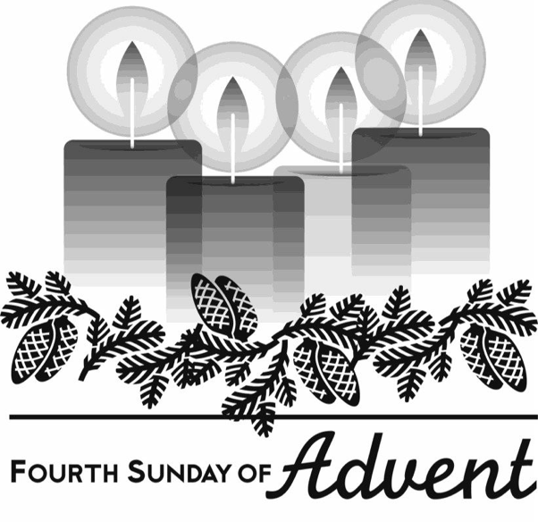Write a letter, poem, or song to Jesus and/or to each person in your family. Wrap it in a gift box with special (maybe white or gold) wrapping paper to be opened on Christmas Day.

# **Advent**

The season of Advent is a time when individuals prepare their hearts to receive Christ. Advent refers to the “coming” or “arrival” of Jesus Christ. The first Sunday of Advent occurs near or upon November 30 each year – November 28th this year. It always includes four Sundays and varies in length from twenty-two to twenty-eight days. Advent ends with Christmas Eve.

Advent can be celebrated at church and at home. .

This devotional booklet includes a guide for each week centered around the Advent wreath candles. While there are no “official” names for the four candles, many people observe the first candle as the candle of Hope, the second Peace, third Joy, and fourth Love. Each week includes scripture, a brief devotional, a carol, a prayer, and ideas for discussion and activities throughout the week.

May your Advent season be filled with light and love.

**A Candle Lighting Prayer**

*One:* Lord, by your presence, light up the past …

*All:* That, through remembering, we may live more faithfully in the present.

*One:* Light up the present …

*All:* That, through seeing, we may help shape the future.

*One:* Light up the future …

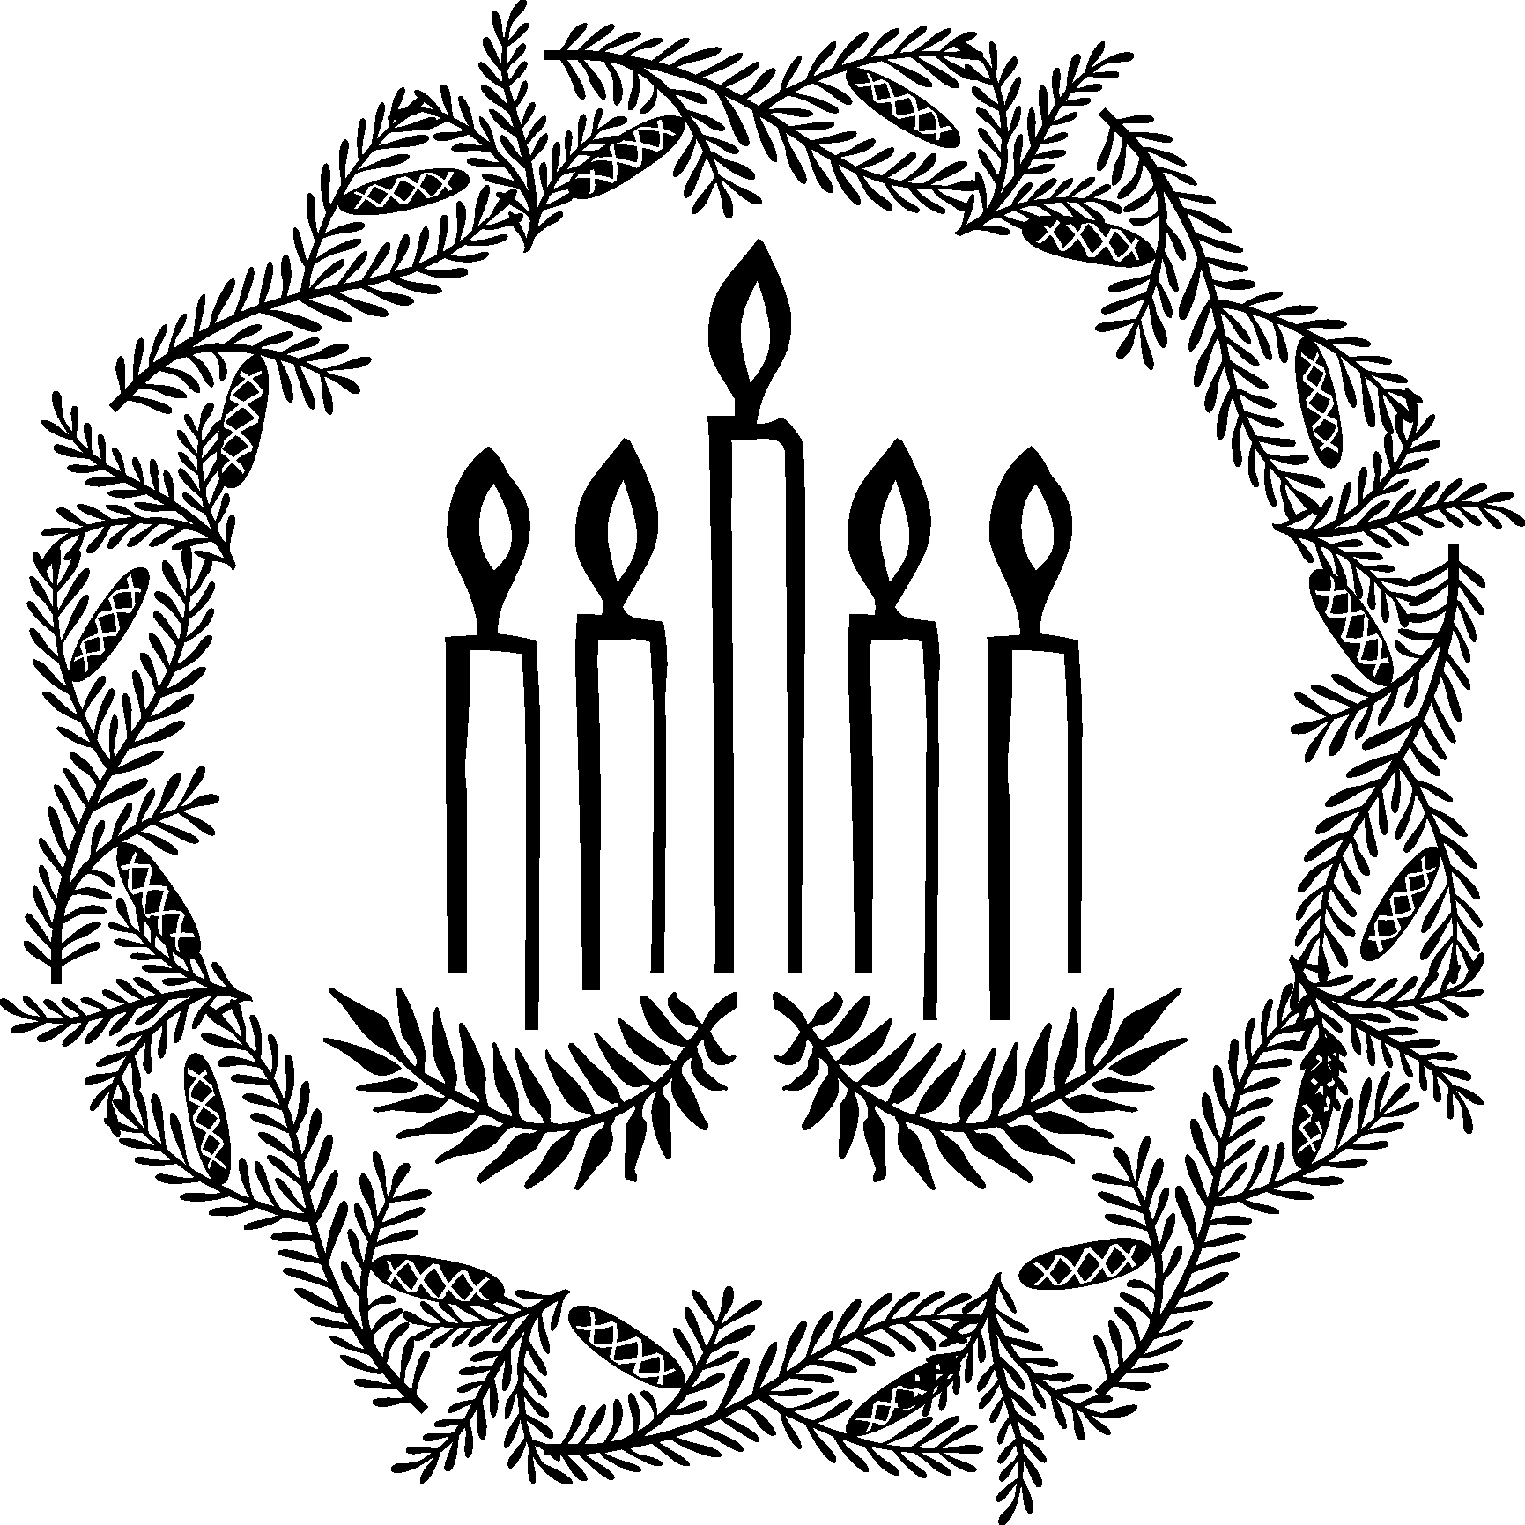*All:* That, through waiting, we may know the joy of your coming Kingdom.

